**LAPORAN PRAKTIKUM PEMOGRAMAN BERORIENTASI OBJEK 4**

**“Tugas Polymorfisme”**



Nama : Diva Cahya Hakim

NPM : 4523210037

**Dosen : Adi Wahyudi Pribadi**

**S1 Teknik Informatika**

**Fakultas Teknik**

**Universitas Pancasila**

**2024/2025**

1. Single

Mobil.java

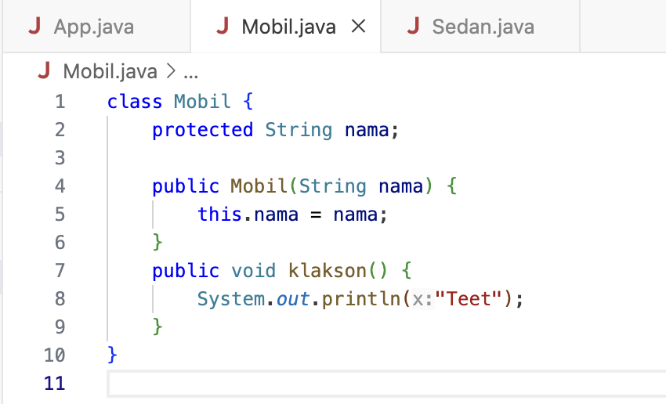

Sedan.java

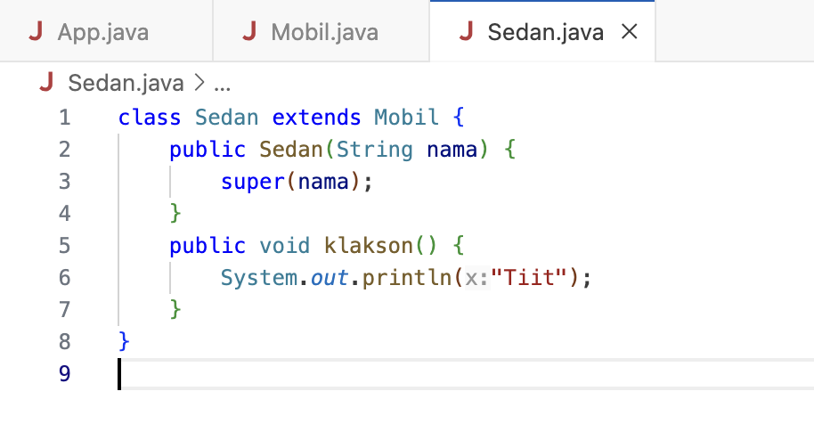

App.java

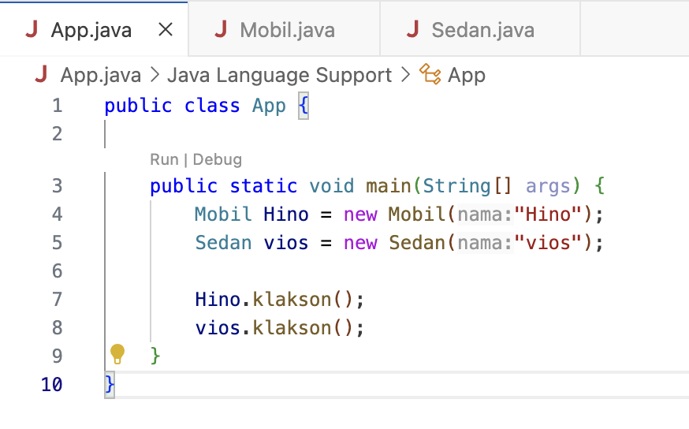

Hasil Run

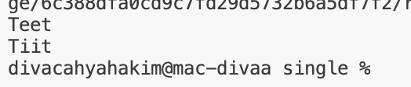

1. Multilevel

Binatang.java

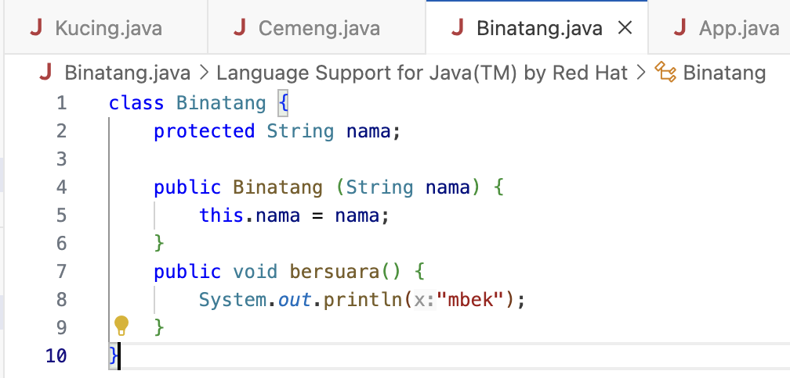

Cemeng.java

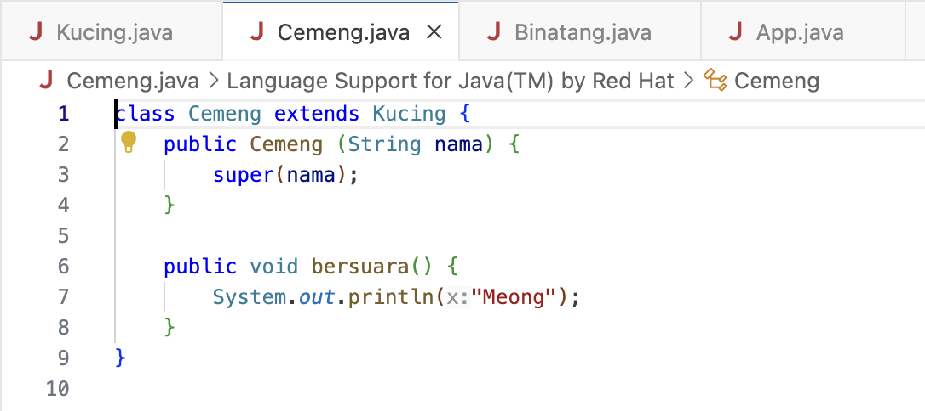

Kucing.java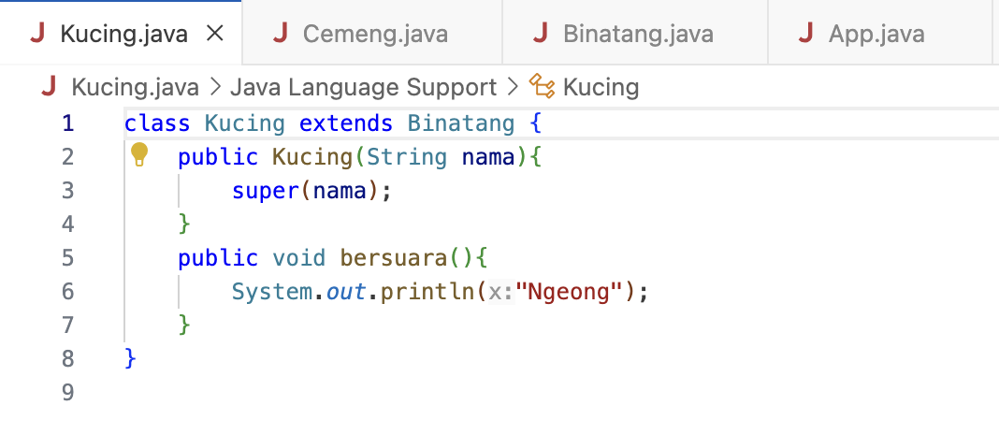

App.java

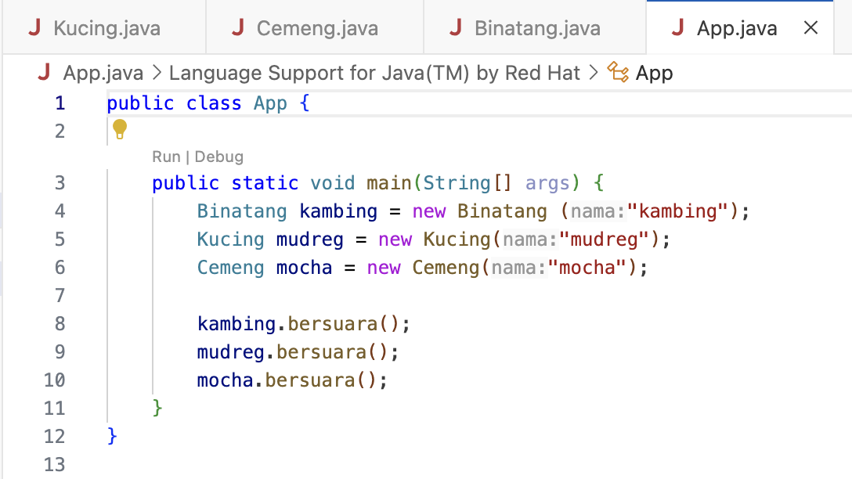

Hasil Run

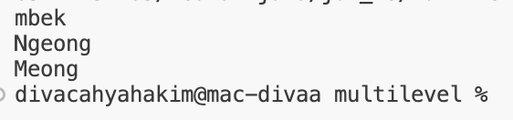

1. Hierarchical

Dosen.java

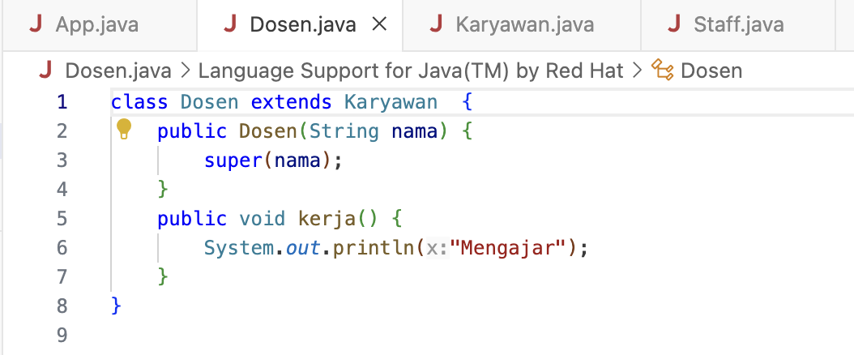

Karyawan.java

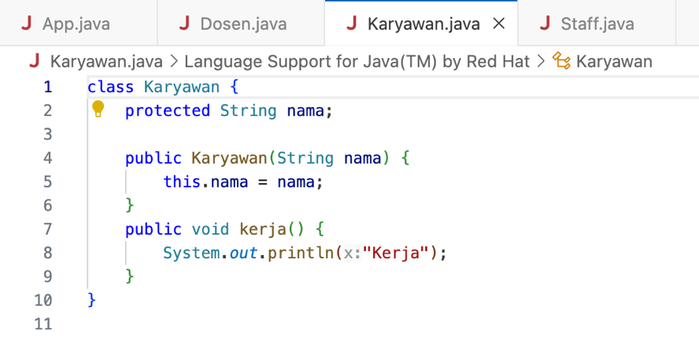

Staff.java

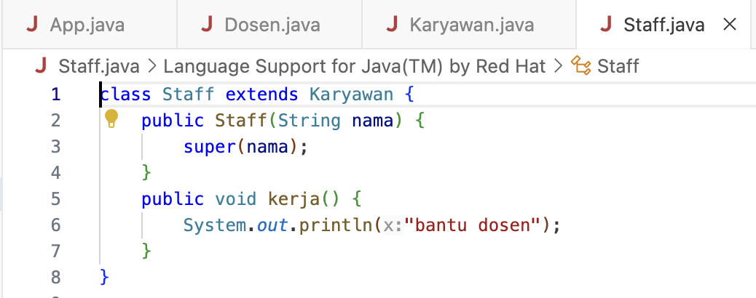

App.java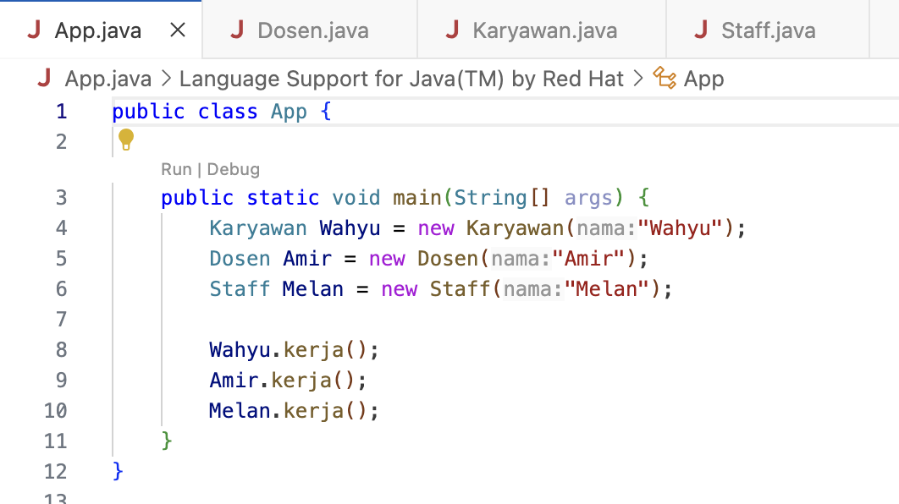

Hasil Run

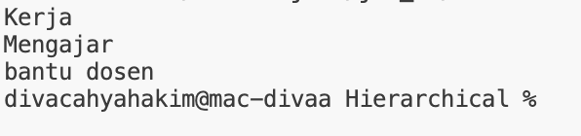

1. Implementasi Polymorphism
2. Method Overloading/Static Polymorphism

MobilSport.java

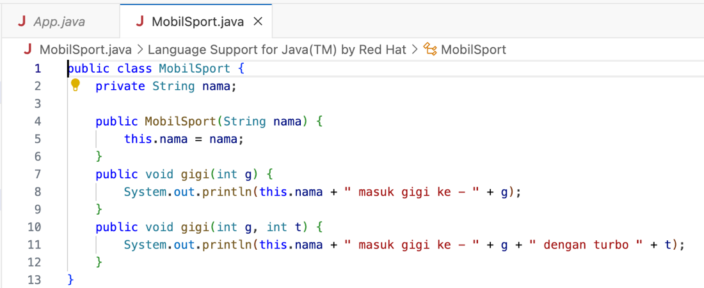

App.java

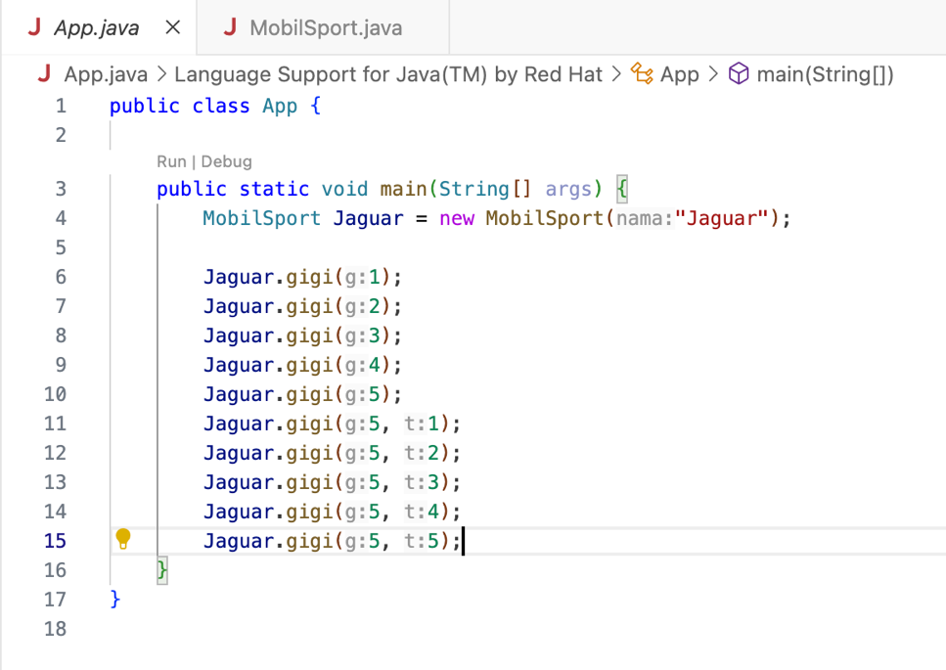

Hasil Run

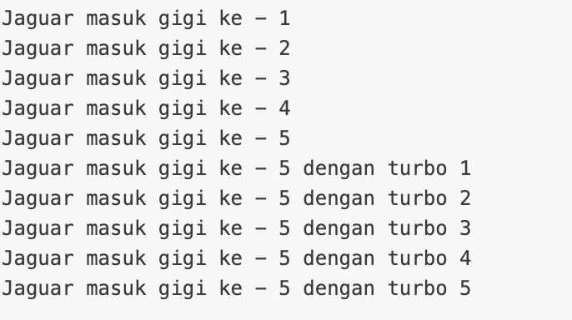

1. Method Overriding/Dynamic Polymorphism

BangunDatar.java

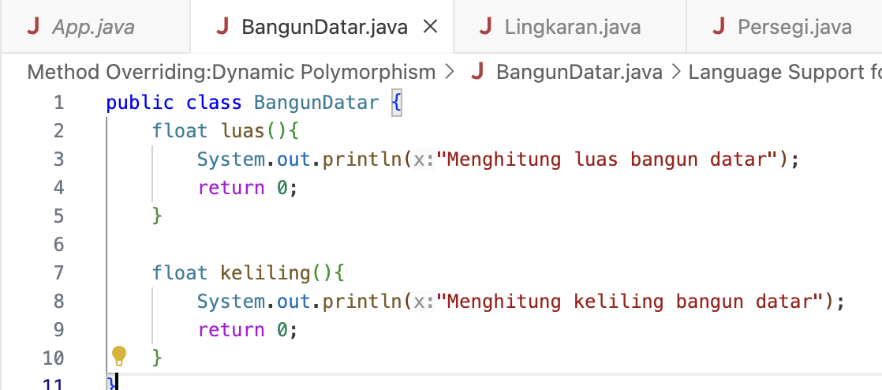

Lingkaran.java

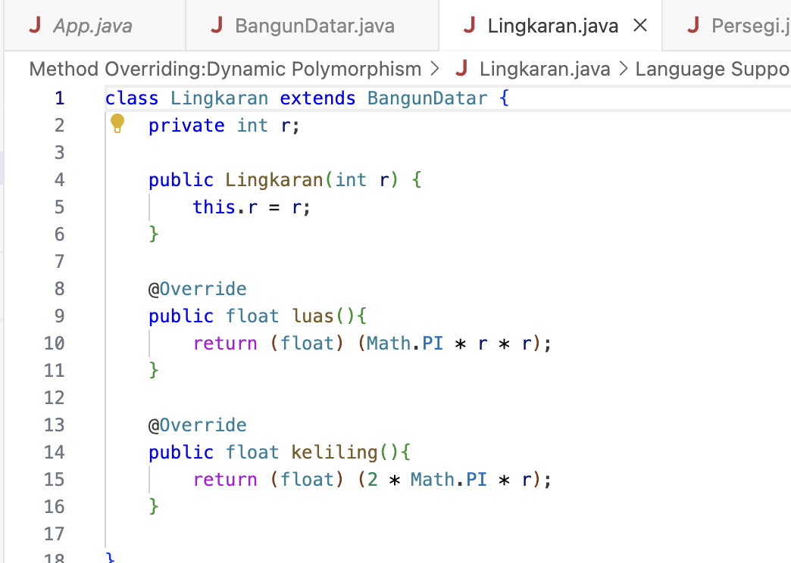

Persegi.java

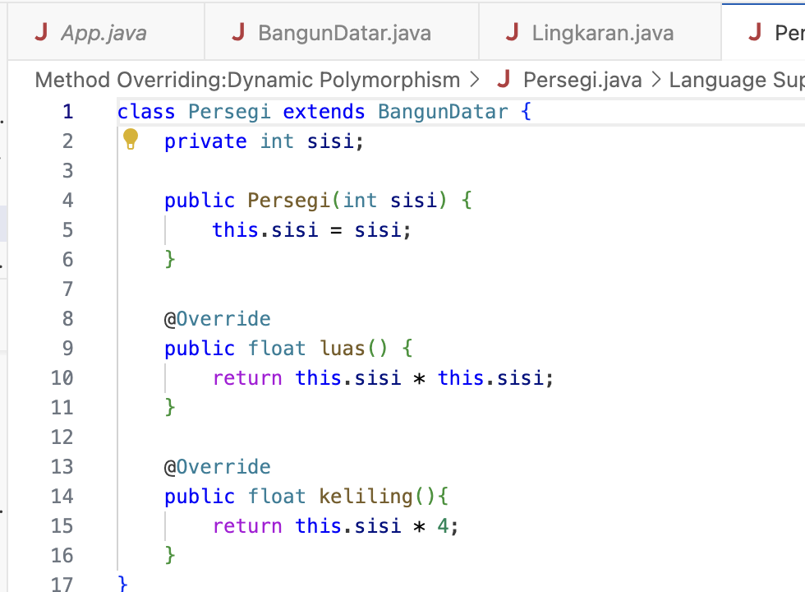

Segitiga.java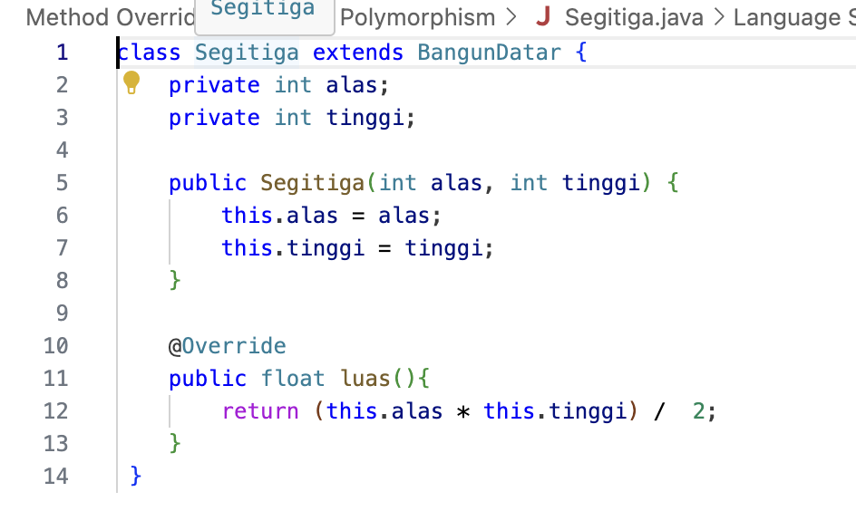

App.java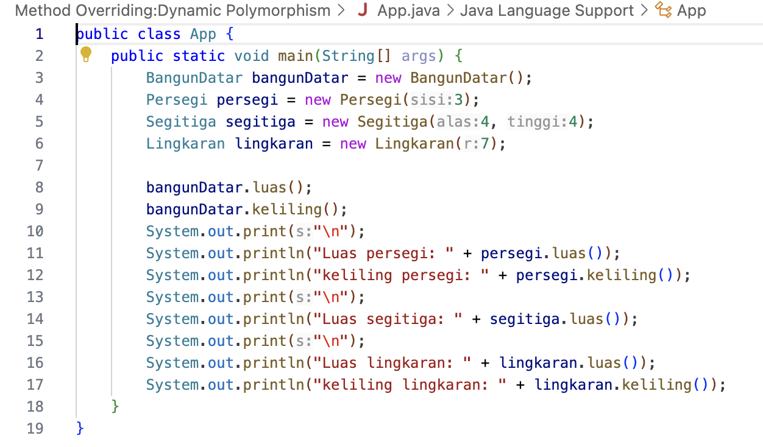

Hasil Run

